Blockchain Engineering
Assignment 003
Name: Aman Sarkar
Ht.no: 2303A51273
Batch: 05

Problem Statement -
Develop a basic Solidity smart contract that allows users to:
• Store a message on the blockchain
• Update the message
• Retrieve the stored message
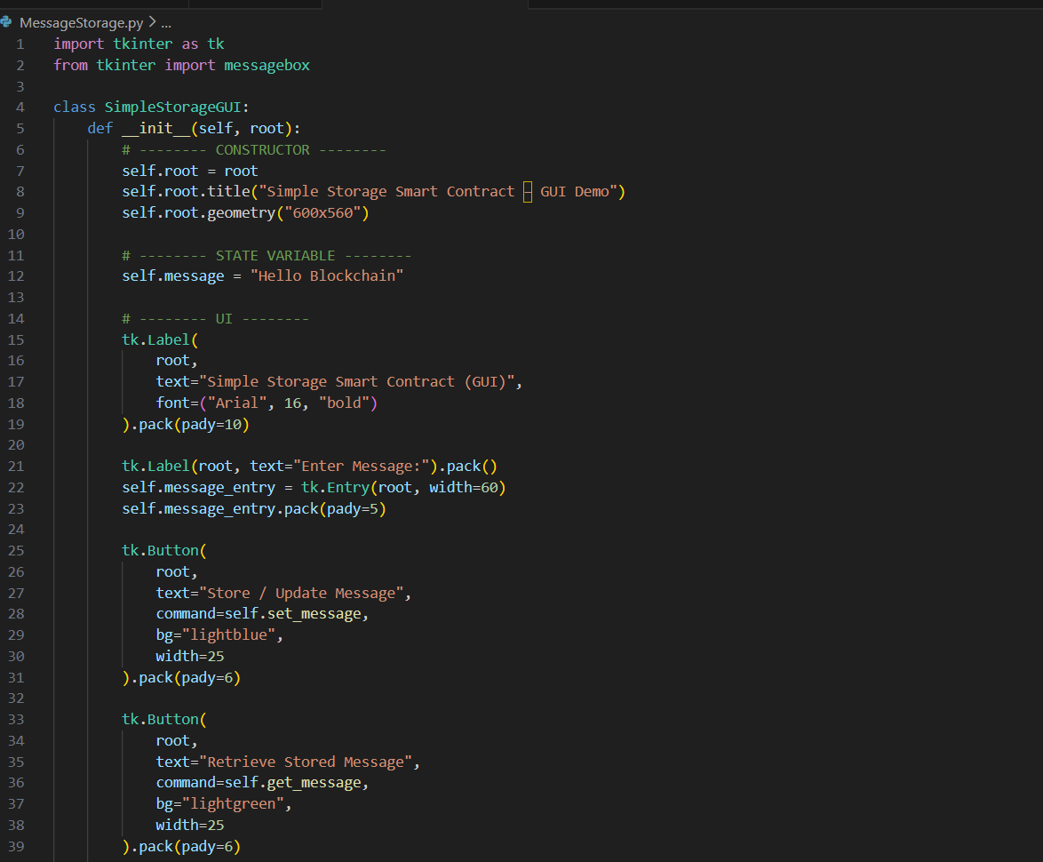
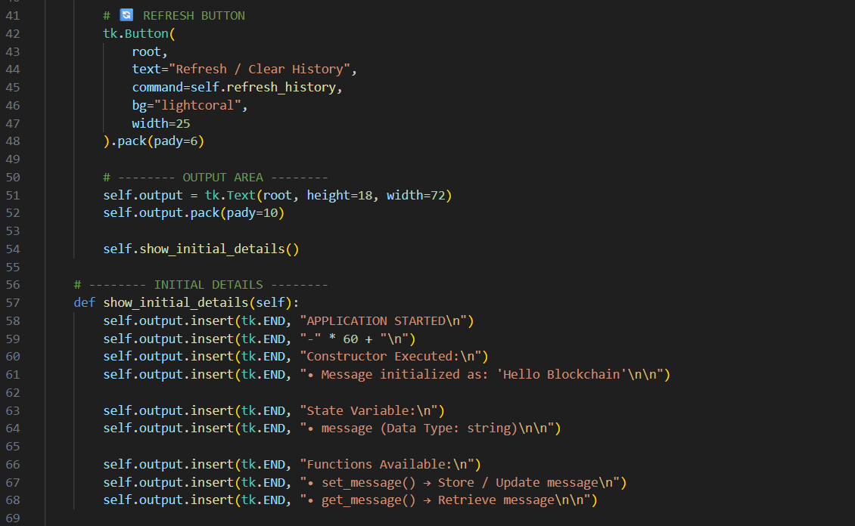
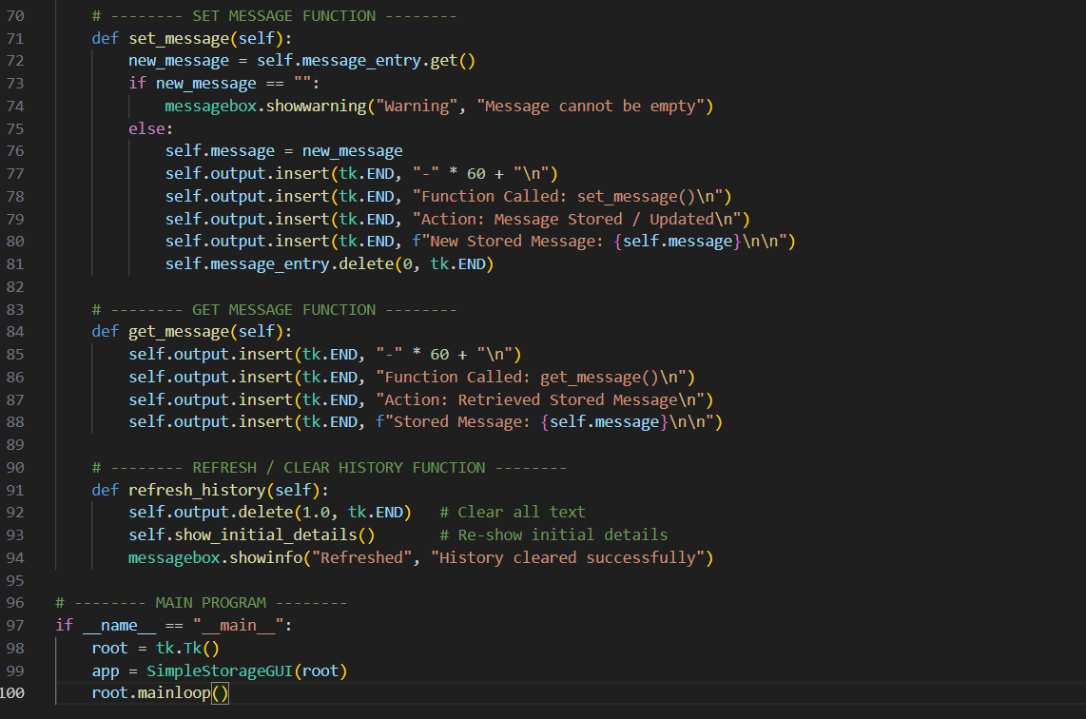

Output -
